**Exercise 4.2.2**

**(a) Generate the 2000-ball histogram in Example 4.2.2.**

**(b) Verify that the resulting relative frequencies f(x) satisfy the equation**

**f(x) ∼ (2^x * exp(−2))/x! x = 0, 1, 2, . . .**

**(c) Then generate the corresponding histogram if 10 000 balls are placed, at random, in 1000 boxes.**

**(d) Find an equation that seems to fit the resulting relative frequencies well and illustrate the quality of the fit.**

**Resposta:**

**A)**

Código na pasta 422

Resultado:

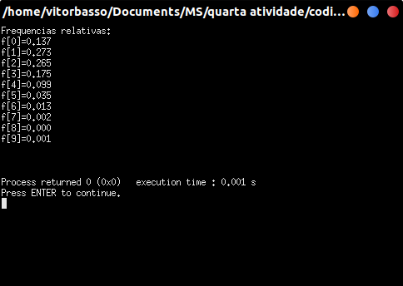

Com o seguinte histograma como resultado:

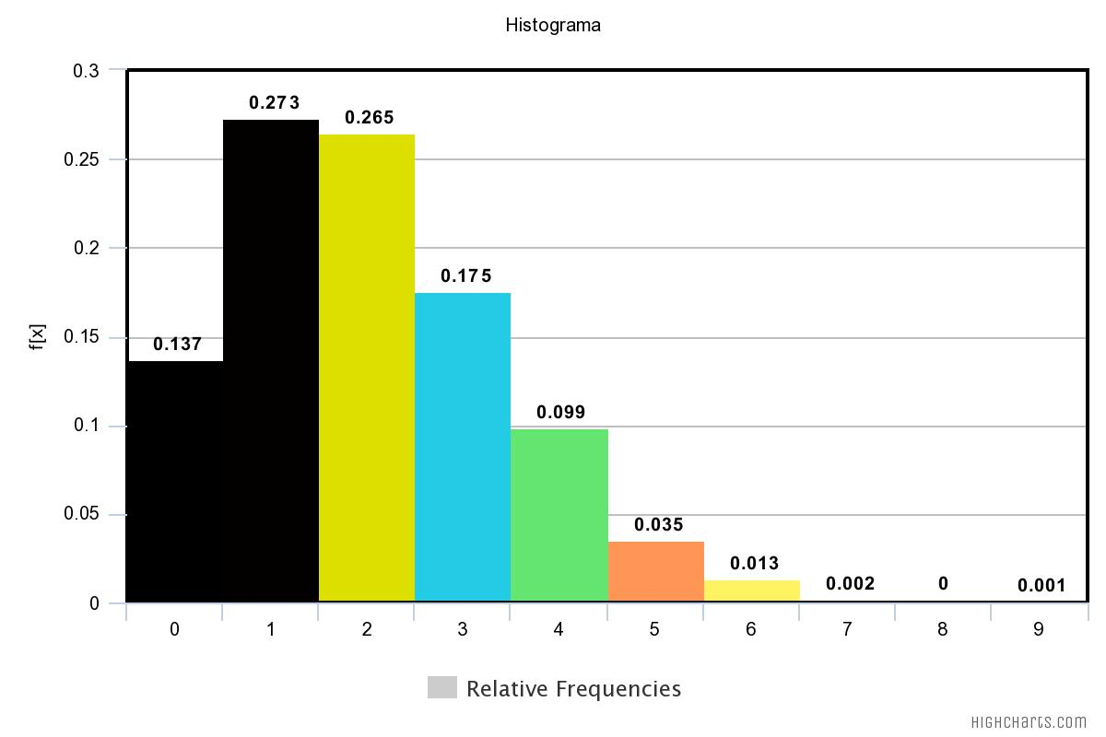

**B)**

Conferindo:

f[0] = (2^0 exp^(-2))/0! ~ 0.135

f[1] = (2^1 exp^(-2))/1! ~ 0.273

f[2] = (2^2 exp^(-2))/2! ~ 0.265

f[3] = (2^3 exp^(-2))/3! ~ 0.175

f[4] = (2^4 exp^(-2))/4! ~ 0.090

f[5] = (2^5 exp^(-2))/5! ~ 0.036

f[6] = (2^6 exp^(-2))/6! ~ 0.012

f[7] = (2^7 exp^(-2))/7! ~ 0.003

f[8] = (2^8 exp^(-2))/8! ~ 0.000

f[9] = (2^9 exp^(-2))/9! ~ 0.001

**C)**

Mesmo código da pasta 422 - Alterando BOLAS pra 10000 e MAXIMO para 22

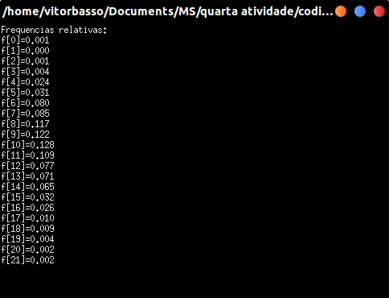

Com o seguinte histograma como resultado:

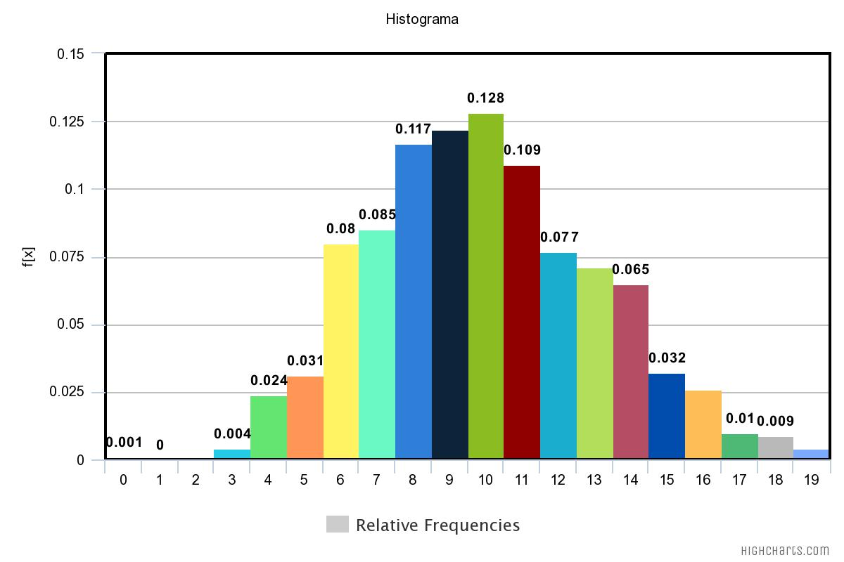

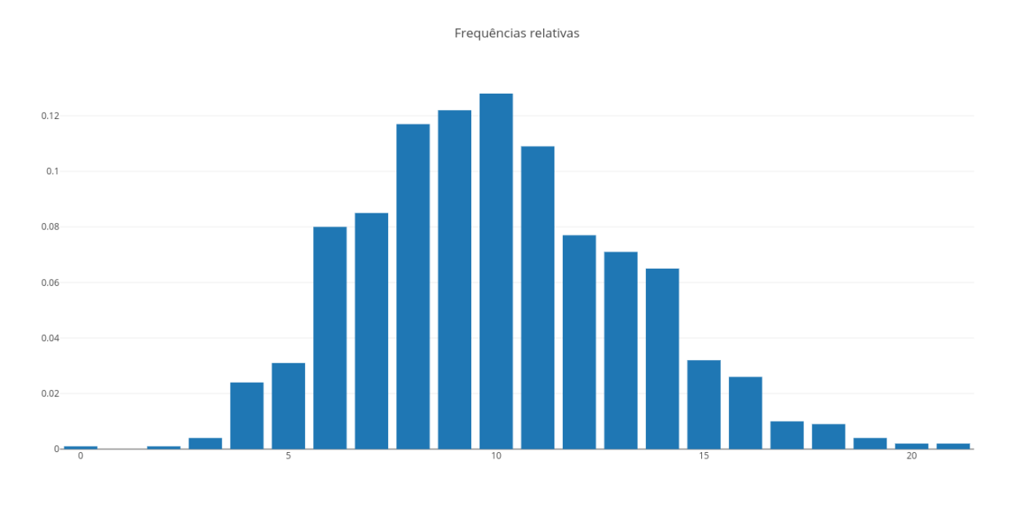

**D)**

**Exercise 4.3.1**

1. **Use program cdh to construct a continuous-data histogram like the one on the left in Example 4.3.1, but corresponding to a needle of length**

**r = 2.**

**(b) Based on this histogram what is the probability that the needle will cross at least one line.**

**(c) What is the corresponding axiomatic probability that a needle of length r = 2 will cross at least one line?**

**Resposta:**

**A)**